Week 1.
Number activities – Mild
Number  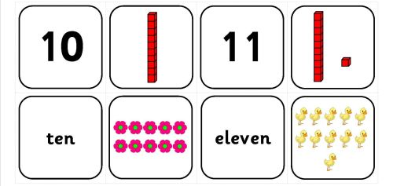  What I am learning:  Recognise all numbers to 20  Put numbers in order  Count accurately | - Write out numbers around the house and go a number hunt to find them and put them in order.  - Lay out numbers on the ground and splat with a spoon or even a nerf gun! | - Count out a handful of objects found within the house such as a handful of pasta, a spoon of rice, pegs in your peg basket.
- Play snakes and ladders, try going backwards as well. | - Play the game below on the computer  - https://www.topmarks.co.uk/ordering-and-sequencing/caterpillar-ordering you can set the numbers on this game to a level that children are able to manage | - Use a large paint brush and water to write the three numbers which come before or after a number you make with 2 dice.
Week 1.
Number activities – Hot
Number  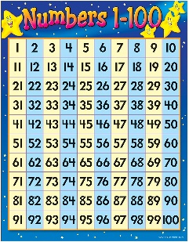  What I am learning:  I can recognise and write all numbers to 30 | - Roll three dice to make a 2 digit number.  - Write the number down.  - Draw the number, i.e 26 you can draw two tens and 6 ones. | - Count out a handful of objects found within the house such as a handful of pasta, a spoon of rice, pegs in your peg basket.  Remember to help with larger numbers group them in 10s.
- Write a number problem and see if your family can guess the number you are thinking of. For example, this number is 4 more than 24 but less than 30. | - Play the game below on the computer  - https://www.abcya.com/games/number_bingo | - Play the game below on the computer  - https://www.topmarks.co.uk/ordering-and-sequencing/caterpillar-ordering

Week 1
Number activities – Spicy
Number  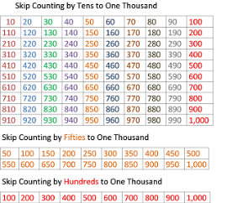  What I am learning:  Read, recognise and write numbers to 100  Order numbers to 100  Understand what each digit is worth | - Practise your number bonds to 10 and 20.  e.g. 7 + ? = 10 17 + ? =20  2 + ? = 10 13 + ? = 20  9 + ? = 10 11 + ? = 20  How quickly can you work them out mentally? Can you get faster? | - Practise counting to 50 in 2s and 5s.  Can you time yourself each day and get quicker?
- Play the Addition Paddle game in your Maths Packs. | - Play the games below on the computer  - https://www.topmarks.co.uk/ordering-and-sequencing/caterpillar-ordering  Choose the option for 0-100 forwards and backwards | - Choose coins to make a specific sums of money.  - https://www.doorwayonline.org.uk/activities/cashing-in/cashing-in.html

