Week 2
Addition activities- Mild
Addition  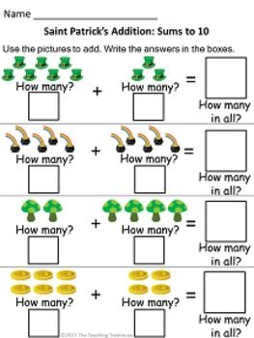  What I am learning:  Add up 2 numbers within 10 using objects or fingers.  Hide one of the piles of objects and see if you can count up in your head. | Number Tower- Card Game  You need one pack of playing cards for1 player, and someone to check the tower.  Choose a NUMBER TOWER to build e.g. 8  Build the tower using pairs of cards that make 8 - look through the cards to find the cards you need.  Players can check they have built their tower correctly by counting.  Challenge- Record the number pairs which make the number in your jotter. | Pasta Subtraction – Dice Game  - Start with a pile of pasta.  - Throw a dice, say how many pieces of pasta will be left if you subtract that number.  - Take away the pieces of pasta to check.  - The person to take the last piece wins.
- Play snakes and ladders. If you land on a snake or ladder, answer a question correctly to stop you going down and to allow you to go up. You can go up and down snakes and ladders. | - Play the maths games below on a computer.  - https://www.topmarks.co.uk/Flash.aspx?f=PostSortingcalculationsv2  - https://www.arcademics.com/games/mission | 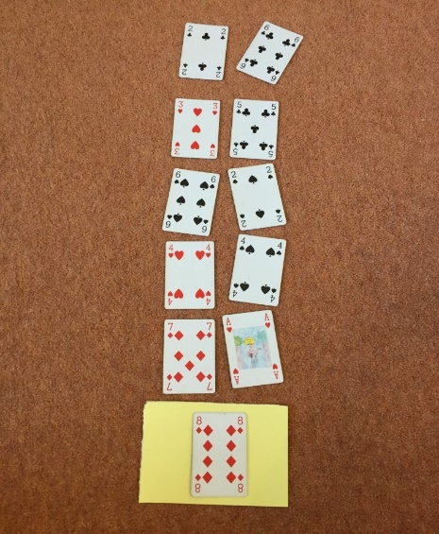

Week 2
Addition activities – Hot
Addition  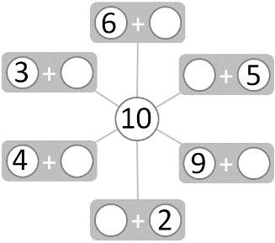  What I am learning:  Fact families within 10. | - Write 0 to 10 out on small pieces of paper and lay them out face down.  - Turn over 2 cards- if they make 10 keep them, if not put them back. | - Take 10 toys and split into 2 different groups each time. Draw them and write the sums you make in your jotter. Can you find 11 different sums?
- Play snakes and ladders. If you land on a snake or ladder, answer a question correctly to stop you going down and to allow you to go up. You can go up and down snakes and ladders. | - Play the maths games below on a computer. Choose 10 for both games.  - http://www.ictgames.com/saveTheWhale/index.html  - https://www.abcya.com/games/fuzz_bugs_number_bonds  - https://www.mathplayground.com/number_bonds_10.html | - Use lego bricks to build explore these number facts  Choose a number between 11-20  Make your number with two different colours  Ask someone in your family to write out the number story for your model i.e 7 + 4 = 11

Addition activities – Spicy
Addition  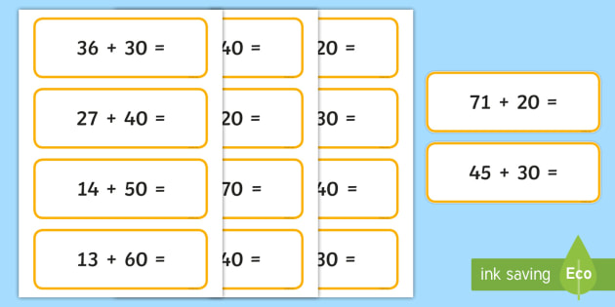  What I am learning:  I can add multiples of ten to a number. | - Work with a partner.  - Write a multiple of ten to make the number sentences true.  5 + ? + ? = 75 ? + 3 + ? = 73  ? + ? + 4 = 84 ? + 7 + ? = 97 | 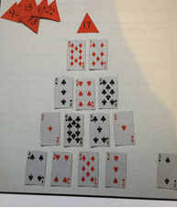
- Play snakes and ladders. If you land on a snake or ladder, answer a question correctly to stop you going down and to allow you to go up. You can go up and down snakes and ladders. | - Play the maths games below on a computer.  - http://www.snappymaths.com/addition/addw10/interactive/addm10imin/addm10immm.htm  - http://www.snappymaths.com/addition/addm10m100/interactive/addm10to2dattack.htm  - http://www.snappymaths.com/addition/addm10m100/interactive/addm10to2d/addm10to2dint.htm | - Pyramid Card Game  Select target number between 10 – 20  Use addition and subtraction to make your pyramid shape with each line totalling the target number. Players place the cards out using 2 cards, then 3 cards, then 4 cards and finally 5 cards

