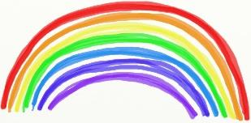
Term 4 Week 5 P1-3 Home Learning Guide – Week Beginning: 11/05/2020

Choose one; mild, hot or spicy focus for each area | Literacy | Numeracy and Maths | Health and Wellbeing
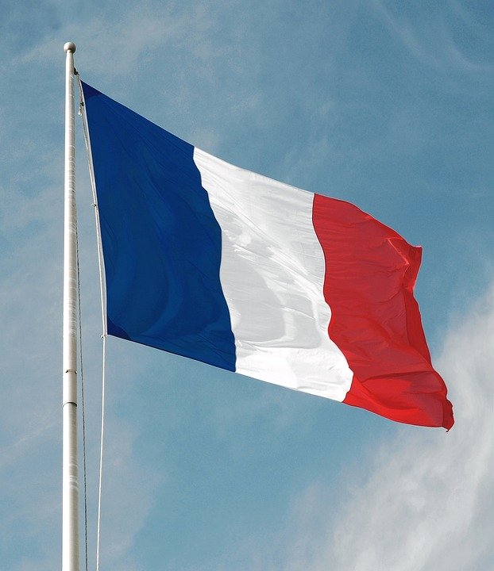  French phrase to try I feel good–  Je me sens bien  Hear how to say it here…  https://www.youtube.com/watch?v=NGvQU_f4tA0  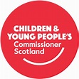  Right of the Week  Article 14  Freedom of thought, belief and religion  Please use this document as guidance to support your child’s learning at home. There are no expectations that all activities will be completed.  Should you require additional ideas and support, please look at the ‘Family Learning’ tab on the school website. | Spelling | Off-line | Physical Health  Build your own indoor or outdoor den!  This is a whole school activity-  for more details go to  https://sites.google.com/glenurquharthigh.org.uk/family-learning-gups/home  Social and Emotional Health  Kindness  Do something kind for someone in your family every day.
 | Mild he, I, in, is, it  Hot at, no, not, on, one  Spicy do, has, her, here, if  Please see documents called  Early level spelling and  First level spelling for ideas on how to practice. | Please see document called  Term 4 Week 4 Numeracy.  There are Mild/Hot/Spicy challenges to choose from to support number recognition and sequencing. There are online and offline options here. You can always look at options over two grids if you need more ideas.
 | Reading
Talk for Writing Story (in booklets on blog)
Log-in to Giglets to see your assigned book.
Please also see Literacy activities Week 5.
 | Writing- | Online
 | Write about something kind you have done this week. | Please find links in Numeracy grids- Week 5 and log-in to Education City to play assigned games.
 Learning across the Curriculum
Religious and Moral Education
We are learning that symbols are used to mean different things.

Mild: Make a good luck card for a friend.

Hot: Make a list of good luck symbols. You can use the Internet to help you.

Spicy: Write an acrostic poem for luck. This means you start each line of the poem with each letter is the word Luck.
Luck is when things go well. What could you write for the second line of the poem starting with U?
U
C
K

Right of the Week- Article 14 - Freedom of thought, belief and religion.
This article guarantees every child's right to think and believe what they choose and to practice their religion, as long as they are not stopping others from enjoying their rights. Please find optional activities to learn more about Article 14 on the school website. https://sites.google.com/glenurquharthigh.org.uk/family-learning-gups/home

Music
Body Percussion, Activity 4
https://youtu.be/jQxYOLOJUbg

Science (You can watch both if you like.)
Mild Watch this video- it has frog spawn to see up close and a tadpole story….
https://www.youtube.com/watch?v=t0x6M42m3IY&list=PLC01BB55A1A761CB0
Hot Watch this video – watch the funky farmer https://www.youtube.com/watch?v=JZiSIdtRf2I You get to see Toad spawn in this video, check it out! You also see the tadpoles swimming in great detail if you watch until the end.
Write down 1 new piece of information you have learnt.

