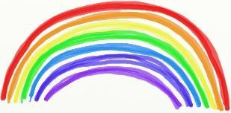
Term 4 Week 6 P1-3 Home Learning Guide – Week Beginning: 18/05/2020

Choose one; mild, hot or spicy focus for each area | Literacy | Numeracy and Maths | Health and Wellbeing
  French phrase to try  My name is……….  Je m'appelle  Hear how to say it here…  https://www.youtube.com/watch?v=reoaRW0axqg  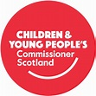  Article 28  The Right to Education  Please use this document as guidance to support your child’s learning at home. There are no expectations that all activities will be completed.  Should you require additional ideas and support, please look at the ‘Family Learning’ tab on the school website. | Spelling | Off-line | Physical Health  Daily challenge:  See if you can spend 20 minutes a day doing anything you choose which makes your heart beat faster!  At the end of the week, decide which activity made your heartbeat change the most? Why do you think this?  Social and Emotional Health  See the Fun Family Movie night document - available to download from the blog.
 | Mild a, and, that, of, was  Hot new, said, she, so, they  Spicy if, into, like, look, made  Please see documents called  Early level spelling and  First level spelling for ideas on how to practice. | Please see document called  Term 4 Week 6 Maths- Money.  There are Mild/Hot/Spicy challenges to choose from.  There are online and offline options here. You can always look at options over two grids if you need more ideas.
 | Reading
Log-in to Giglets to see your assigned book.

Please also see Literacy activities Week 6.
 | Writing- | Online
 | I am learning to write instructions.  See Literacy grid. | Please log-in to Education City to play assigned games.
 Learning across the Curriculum

Religious and Moral Education

We are learning how symbols can affect our daily lives.

Mild: Make a peace (no more fighting) symbol using blue tac/plasticine/play dough.

Hot: Find out what some symbols of peace are.

Spicy: Design a poster showing why we must be at peace (not fight with) others.

Right of the Week-

Article 28- The Right to an Education

Activities related to this focus can be found on the Glenurquhart Primary School website - Family Learning tab.
https://sites.google.com/glenurquharthigh.org.uk/family-learning-gups/home

