Week 7 Mild - Mental Maths skills and Time
Play link: What’s the time Mr Wolf
Have a go at this Time Quiz  https://www.educationquizzes.com/ks1/maths/year-1-time-telling-the-time/ | Clocks  Can you use materials in your garden to make a giant clock face? | Days of the Week and Months of the Year  Can you learn the days of the week and months of the year in the correct order? Can you say which day comes before or after a chosen day?
O’clock and Half Past  Login to Active Learn and have a go at the game assigned to you – you can start at bronze level and work your way to gold! | Rainbow Maths Quiz  Go to  https://www.bbc.co.uk/bitesize/articles/zrm992p  Give Cloud rating 1 a go, there are different challenges to try in here which start easy and get harder.  If these questions are easy for you, try Cloud rating 2!  Write down your answers and then listen to check if you were correct. | Snap it to 5 and 10  Make a tower using 5/10 lego/duplo bricks.  Hide it behind your back and snap the tower.  Show one part to your partner- they need to tell you how many you hiding as quickly as they can.  Take turns.

Week 7 Hot – Mental Maths Skills and Time.
Play link- What’s the time Mr Wolf
Snap to 20  Make a tower using 20 lego/duplo bricks.  Hide it behind your back and snap the tower.  Show one part to your partner- they need to tell you how many you hiding as quickly as they can.  Take turns. | Rainbow Maths Quiz  Go to  https://www.bbc.co.uk/bitesize/articles/zrm992p  Give Cloud rating 1 a go, there are different challenges to try in here which start easy and get harder.  If these questions are easy for you, try Cloud rating 2!  Write down your answers and then listen to check if you were correct. | Mental Maths Games  Check out ‘Zeno Family Math Game’ sheet (blog) and have a go at playing these games.  Guidance  Always start within number range 0-10 first. Only move to 0-20 if your child is secure and can answer questions 0-10 automatically.
O’clock and Half Past  Login to Active Learn and have a go at the game assigned to you – you can start at bronze level and work your way to gold! | With support, write out the days of the week onto pieces of paper (writing in different colours might help you learn them)  - Ask someone to muddle them up- can you put them in order again?  - Pick out one- can you say which day comes before and after the one you have? | Make a timetable of your day in your jotter.  Look at a clock and draw the time in your jotter.  You could record what time you had breakfast, lunch, dinner, bath, a walk or any other activities.
Week 7 Spicy – Mental Maths Skills and Time
Play link- Set yourself some challenges (like run up and down the garden 10 times) and time how long you take to do it. Can you get quicker?
Card Game  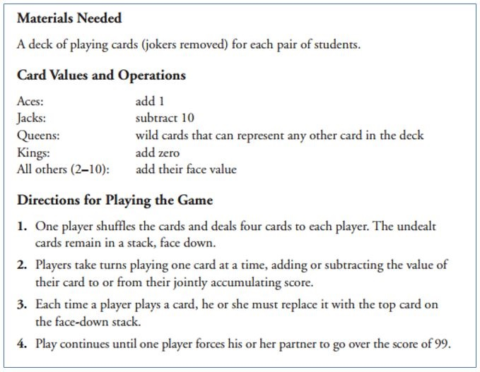 | Rainbow Maths Quiz  Go to  https://www.bbc.co.uk/bitesize/articles/zrm992p  Give Cloud rating 2 a go, there are different challenges to try in here which start easy and get harder.  If these questions are easy for you, try Cloud rating 3 as well.  Write down your answers and then listen to check if you were correct. | Mental Maths Games  Check out ‘Zeno Family Math Game’ sheet (blog) and have a go at playing these games.  Guidance  Start within 0-20 first, and only use larger numbers if your child can answer these quickly and confidently.
O’clock, Half past, quarter past, quarter to  Login to Active Learn and have a go at the games | Time Facts  With support, copy and complete the following into your jotter.  60 seconds = __ minute  60 minutes = __ hour  __ hours = 1 day  7 _____ = 1 week  12 months = __ year | Make a timetable of your day in your jotter.  Look at a clock and draw and then write the time in your jotter.  You could record what time you had breakfast, lunch, dinner, bath, a walk or any other activities.

