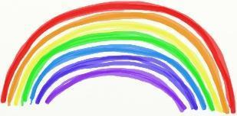
Term 4 Week 7 P1-3 Home Learning Guide – Week Beginning: 25/05/2020

Choose one; mild, hot or spicy focus for each area | Literacy | Numeracy and Maths | Health and Wellbeing
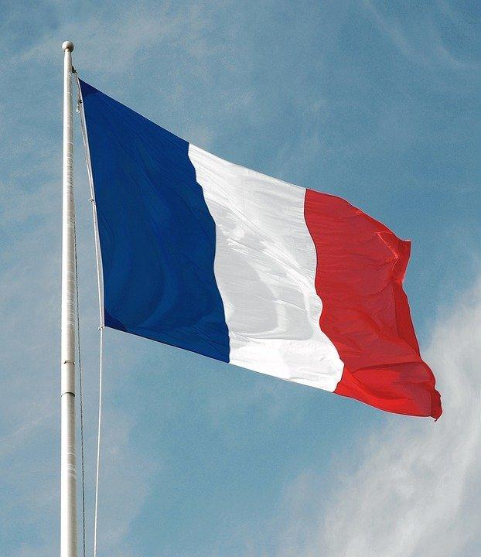  French  Find out how to say your favourite food in French. You can share on the Jamboard!    Article 15  Freedom of Association  Please use this document as guidance to support your child’s learning at home. There are no expectations that all activities will be completed.  Should you require additional ideas and support, please look at the ‘Family Learning’ tab on the school website. | Spelling | Off-line | Physical Health  Kids work out 1:  https://www.youtube.com/watch?v=L_A_HjHZxfI  Kids work out 2:  https://www.youtube.com/watch?v=FrRDG4krjv8  Yoga with Adrienne -Rainbow  https://www.youtube.com/watch?v=dF7O6-QabIo  Social and Emotional Health  This week this is linked to writing- what thoughts did you have about which friends to take and why?
 | Mild he, the, is, to, in  Hot we, when, with, you, all  Spicy make, me, more, much, must  Please see documents called  Early level spelling and  First level spelling for ideas on how to practice. | Please see document called  Term 4 Week 7 Mental Maths and Time.  There are Mild/Hot/Spicy challenges to choose from to support number recognition and sequencing. There are online and offline options here. You can always look at options over two grids if you need more ideas.
 | Reading
Please find Talk for Writing booklet which includes a story.
Read for enjoyment- choose your own book to explore.
 | Writing- | Online
 | This week, please send your teacher an email and write about who you would take with you to a desert island and why? Choose no more than 2 friends in your classroom. | Please log-in to Active Learn to play assigned games.
 Learning across the Curriculum

Religious and Moral Education

We are learning about what makes a sign/symbol effective

Mild: Find 3 signs/symbols in your home. Talk about how each one makes you feel and why.

Hot: Make a list of what makes a good sign/symbol.

Spicy: Make up 3 new signs/ symbols of your own. Write what each shows and why you chose this new design

Right of the Week-

Article 15 - Freedom of Association - I have the right to meet with friends and to join groups.

Activities related to this focus can be found on the Glenurquhart Primary School website - Family Learning tab.
https://sites.google.com/glenurquharthigh.org.uk/family-learning-gups/home

Music

Please find the last lesson of Body Percussion here -
https://youtu.be/lZQEUrMXoR4

Can you make up your own body percussion arrangement? Teach it to your family.

